May 2018
information for restaurateurs

supporting excellence in hospitality in Regional Victoria

Award Partners


goldenplateawards.com.au


Maxim PR and Marketing Pty. Ltd. GPO Box 338 Geelong 3220,
Mobile 0417 150 709 E: events@maximpr.com.au

Golden Plate Awards program
For more than 18 years the Golden Plate Awards Program has helped hospitality businesses in regional Victoria win credible market recognition and engage directly with consumers seeking quality and value for money.
The Awards also provide confidential reports to restaurateurs from the perspective of the customer that help them optimize product offerings and competitiveness.
Factors assessed include food and drink quality and presentation, customer service, use of local foods and beverages, ambiance, and value for money.
The program provides opportunities to network and share ideas with successful industry members, and gain unique insights in market trends and preferences.
benefits of taking part

- confidential reports from expert judges about competitiveness from the perspective of the customer
- confirmation of strengths
- advice on how to add value
- see how your venue performs compared with industry in and outside your region
- participants receive public recognition through social media and media publicity
- participants have their own page in the Awards on-line guide
- participants can take part in unique industry events

2018 Award territories
From 2018 eateries throughout regional Victoria can take part in the Victorian State Awards .
Regional Awards are also presented in:
- Bay & Coasts (Victoria’s coastal areas including Geelong, Bellarine, Surfcoast and Mornington Peninsula)
- Central Victoria (including the Bendigo, Kyneton, Macedon Ranges, Mildura, and Murray regions)
- South Western Victoria (including Ballarat, Daylesford, Grampians, Hamilton, Horsham & Pyrenees)
who can take part
From 2018 any venue serving foods in regional Victoria including restaurants, hotels, cafés, cocktail bars, cellar door wineries or breweries can take part ¹ (NEW).
To qualify they must be nominated by a member of the public via Facebook, E-mail or SMS:
Golden Plate Awards
SMS: 0417 150 709
Email: events@maximpr.com.
Venues nominated will be invited to take part. A simple form and payment of your entry fee is all that must be supplied, plus photos for use in our social media campaigns and your page in the on-line Awards guide.
judging
Judging and the supply of confidential reports are conducted by a team of experienced restaurant reviewers. Venues are visited twice without notice to monitor consistency. Judges sample just enough to ensure a good appreciation of foods and drinks served, including regional wines by the glass only. Up to two persons may be involved to enable sampling of a representative range of dishes.
Venues nominated for Best Coffee by the Award Judges are judged a second time by coffee experts.
The path to the Best Chef State Award involves a cook-off judged by a panel of our senior judges.
Eateries from the Bays and Coast Region (Geelong) also participate in a Regional Best Chef Cook-off and Award.
core values of the Awards
excellence in:
- food and drink quality & presentation
- customer service
- value for money
- use & promotion of local foods & beverages
- ambiance
- consistency of standards

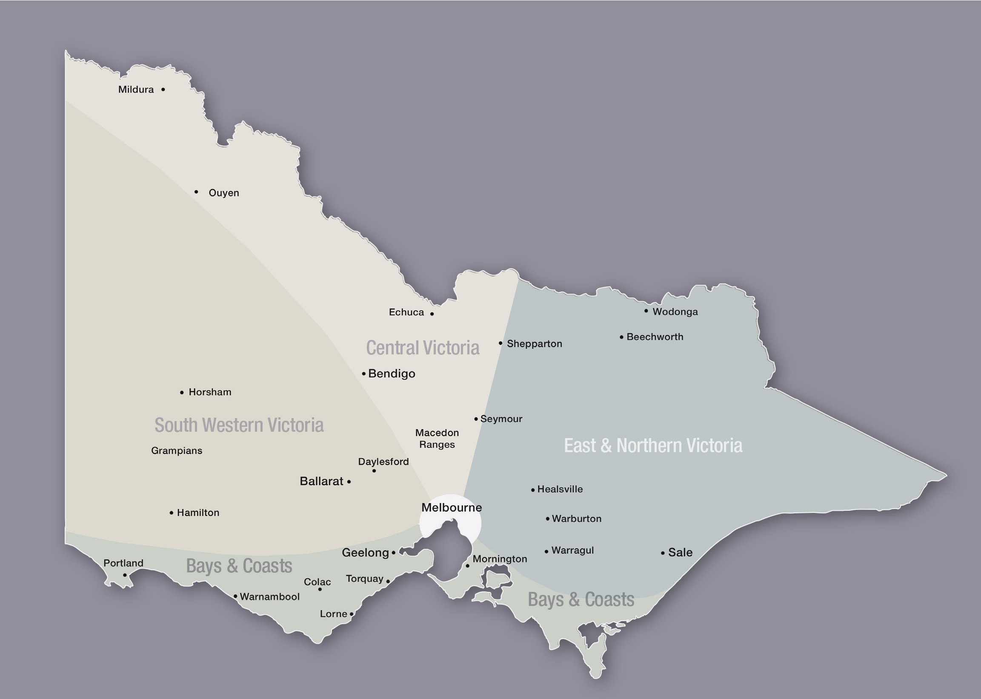
entry fees
The standard entry fees are $390 for licensed venues and $190 for unlicensed venues (plus GST).
Early bird fees also apply.
The entry fees cover the costs of:

- two rounds of judging by expert reviewers
- provision of detailed reports after the first round of judging
- a second report after announcement of the Award Winners
- on-going coverage in the Awards social media campaigns (over 70,000 weekly post-reaches weekly in 2017) and the Award’s on-line guide
- opportunities to take part in Award events and promotions
- provision of POS decals, Award trophies and certificates,

participating venues must:
- Waive the cost of food and drink sampled.
- Provide the Judges with copies of your food and beverage menus.
participating venues are asked to:
- Support the Awards’ social media activities.
- Provide photos for use in the social media campaigns and website guide.
- Discuss the judges’ reports with your staff.
- Contact us if you want to discuss your reports.
- Use the Golden Plate logo and promote the Awards you have won (at the POS, in advertising, social media and websites).
- Let us know of changes and developments in your eatery.
- Use local and regional suppliers of foods and beverages wherever possible.
- Encourage other local eateries to take part.
Golden Plate promotions & events in 2018

- social media campaigns (continuous)
- Share Plate industry forum (NEW - Bays and Coast Region - mid August)
- Best Regional Chef Cook-Off (NEW - Bays and Coast Region - late August)
- Best Chef State Cook-Off (late September)
- Peoples’ Choice Awards (August - September)
- State Awards Gala Dinner (November)

venue categories
contemporary dining
Restaurants featuring high-end cuisine, napery and stemware that typically charge over $80 for two courses.
The 2017 State Winner was Merne at Lighthouse Drysdale (also Regional Winner Vic Coasts and Bays). The Regional Winner for SW Vic was the Perfect Drop Daylesford and for Central Vic La Bonta Kyneton,
casual dining
Restaurants with informal “grazing” style menus that typically charge less than $80 for two courses.
The 2017 State Winner was Belvedere Social Dining Daylesford (also Regional Winner SW Vic), The regional Winner for Victoria Coasts & Bays was Little Red Fox Marcus Hill.
hotel dining
Venues with a public bar providing counter or table service that typically charge less than $60 for two courses.
The 2017 State Winner was Great Ocean Road Brewhouse (also Regional Winner Vic Coasts & Bays). The Regional Winner for Central Vic was the Brougham Arms Bendigo and for SW Victoria Farmers Arms Hotel Creswick.
licensed cafes
Often referred to as “today’s restaurants” licensed cafes serve alcoholic beverages and a good range of light meals, usually provide table service and charge less than restaurants for comparative meals.
The 2017 State Winner was the Talbot Provedore and Eatery (also Regional Winner SW Vic). The Regional Winners for Vic Coast & Bays was Winters Café Newtown and for Central Vic Moto Bean, Malmsbury.
Unlicensed cafes
Un-licensed cafes usually serve breakfasts and a range of affordable light meals and pastries, cakes and snacks during the daytime, and may provide table service.
The 2017 State Winner was the King of the Castle West Geelong (also Regional Winner Vic Coasts & Bays). The Regional Winners for SW Vic was Webster’s Market and Café Ballarat and for Central Vic Edwards Provedore and Eatery, Ballarat.
Cocktail bars and cellar door eateries (includes wineries and breweries - NEW)
This is a new venue category introduced for 2018 to reflect the popularity of these types of venue in Regional Victoria. To qualify, the venues must serve quality foods to accompany the beverages served .
Special Recognition Awards
The Special Recognition Awards focus on key features of hospitality in regional Victoria:
Peter Watson Memorial Award for Best Chef
The winners of the Regional Awards for Best Chef are chosen by the full panel of Judges.
Up to three chefs nominated in each region become Finalists in the State Award Cook-off staged in the showrooms of Comcater Pty. Ltd. in Tope Street South Melbourne.
The competing Chefs are provided with a mystery box of ingredients on arrival and required to prepare and serve an entrée and main to be sampled by a panel of the Awards’ Senior Judges.
The State Winner in 2017 was Matt Carnell from Belvedere Social Dining Daylesford (also regional Winner SW Vic), The Regional Winner for Central Vic was Dave Robson from La Bonta Kyneton and for Vic Coasts & Bays was Adam Langridge from Little Red Fox, Marcus Hill.
The State Winner in 2018 will receive a major overseas travel prize.
most outstanding FOH person
The Winners of the regional and State Awards for Most Outstanding Front of House Person Award are chosen by the full panel of judges.
The State Winner in 2017 was Alison Chapman from the Avoca Hotel, Avoca (also regional Winner SW Vic), The Regional Winner for Central Vic was James Bone from La Bonta Kyneton and for Vic Coasts & Bays was Caleb Fleet for Merne @ Lighthouse Drysdale.
best coffee
Finalists for the regional and State Awards for Best Coffee are chosen by the full panel of judges. The Finalists are then judged again by an expert in Coffee.
The State Winner in 2017 was King of the Castle (also regional Winner Vic Coasts & Bays), The Regional Winner for SW Vic was Larder Daylesford and for Central Vic was Moto Beam Malmsbury.
best menu of local foods
This Award recognises the imaginative use and promotion of local foods on menus, special boards and by wait staff.
A Finalists and Winners for the Regional and State Awards are chosen by the full panel of judges.
The State Winner in 2017 was Tuki Restaurant Smeaton (also Regional Winner SW Vic), The Regional Winner for Central Vic was La Bonta Kyneton and for Vic Bays & Coasts was Jack Rabbit Vineyard, Bellarine.
best menu of local wines, beers & ciders
This Award recognises the use and promotion of local beverages on menus, special boards and by wait staff, and availability of local wines by the glass. The Finalists and Winners are chosen by the full panel of Judges.
The State Winner in 2017 was Belvedere Social Dining Daylesford (also regional Winner SW Vic). The Regional Winners were the Cambrian Hotel Bendigo (Central Vic), and Jack Rabbit Vineyard Bellarine (Vic Coasts & Bays).
best value for money
These awards are based on price and quality for foods, drinks, service, value adding factors, and the overall enjoyment of the dining experiences. The Finalists for are chosen by the full panel of judges and the Winners are chosen by the Lead Judge.
The State Winner in 2017 was Quigley and Clarke, Clunes (also regional Winner SW Vic). The Regional Winners were the Cambrian Hotel Bendigo (Central Vic), and The Pickers Union, North Geelong (Vic Coasts & Bays).
indicative 2018 program timelines

- Facebook/Twitter/Online Guide continuous
- nominations and enrolments April / May
- industry briefings March / April
- first round judging April 1 to June 30
- first Judges’ reports issued from early July
- Share Plate Industry Forum (Geelong) Augt
- Voting for People’s Choice September
- Regional Best Chef Cook-Off September
- State Best Chef Cook-Off late September
- judging of Special Awards October
- State & regional Gala dinner November
- Award Winners announced November
- Final scores & reports issued January 2019

venue judging criteria
The Golden Plate scoring system measures how well eateries achieve their maximum potential. Up to 34 factors with different weightings are considered. The Golden Plate Algorithm makes it possible for any type of eatery to win the highest Awards.
Food represents 30% of total scores for restaurants and hotels, 25% for unlicensed cafes, 20% for licensed cafes and cocktail bars and cellar door eateries. Coffee represent 25% for unlicensed cafes, 20% for licensed cafes, 5% for restaurants & hotels but are not included for cocktail bars and cellar door eateries. Tea is considered a value adding factor for all eateries and hot drinks are a value adding factor for cocktail bars and cellar door eateries. Customer Service and Value for Money represent 20% of total scores each in all eateries, Ambience represents 10% and Hygiene and Customer Safety are pass or fail criteria.

scoring & weighting restaurants & hotels licensed cafés unlicensed cafés cocktail bars &
cellar door eateries
% section % total % section % total % section % total % section % total
food quality & presentation 30% 20% 25% 20%
freshness-texture-flavor-taste combinations 40% 12.0% 40% 8.0% 40% 10.0% 40% 8.0%
appearance & presentation 20% 6.0% 20% 4.0% 20% 5.0% 20% 4.0%
use & promotion of local ingredients 15% 4.5% 15% 3.0% 15% 3.8% 15% 3.0%
range of dishes offered 8% 2.5% 8% 2.5% 8% 2.5% 8% 2.5%
time from ordering to serving 8% 2.5% 8% 2.5% 8% 2.5% 8% 2.5%
time between courses 8% 2.5% 8% 2.5% 8% 2.5% 8% 2.5%
wines, beers, ciders & spirits 15% 10% not applicable 30%
quality 20% 3.0% 20% 2.0% - - 20% 6.0%
choice / varieties available 20% 3.0% 20% 2.0% - - 20% 6.0%
promotion of local beverages 20% 3.0% 20% 2.0% - - 20% 6.0%
availability of local wines by the glass 20% 3.0% 20% 2.0% - - 20% 6.0%
drinks march style of foods served 20% 3.0% 20% 2.0% - - 20% 6.0%
customer service 20% 20% 20% 20%
meet, greet & farewell procedures 20% 4.0% 20% 4.0% 20% 4.0% 20% 4.0%
serving & problem solving skills 20% 4.0% 20% 4.0% 20% 4.0% 20% 4.0%
staff knowledge & ability to offer advice 15% 3.0% 15% 3.0% 15% 3.0% 15% 3.0%
staff attentiveness to customers’ needs 15% 3.0% 15% 3.0% 15% 3.0% 15% 3.0%
drinking water provided 10% 2.0% 10% 2.0% 10% 2.0% 10% 2.0%
timing of service 10% 2.0% 10% 2.0% 10% 2.0% 10% 2.0%
information on menus & specials board 10% 2.0% 10% 2.0% 10% 2.0% 10% 2.0%
value for money 20% 20% 20% 20%
food 30% 3.0% 30% 30% 30% 3.0% 30% 3.0%
drink (including serving of quality teas) 30% 3.0% 30% 3.0% 30% 3.0% 30% 3.0%
service 30% 3.0% 30% 3.0% 30% 3.0% 30% 3.0%
venue’s website, social media & other factors 10% 1.0% 10% 1.0% 10% 1.0% 10% 1.0%
ambience 10% 10% 10% 10%
decor matches styles of food & drink 20% 2.0% 20% 2.0% 20% 2.0% 20% 2.0%
ergonomics of seating & tables 20% 2.0% 20% 2.0% 20% 2.0% 20% 2.0%
cleanliness & clean up procedures 15% 1.5% 15% 1.5% 15% 1.5% 15% 1.5%
acoustics, background music & entertainment 15% 1.5% 15% 1.5% 15% 1.5% 15% 1.5%
suitability of napkins & flatware 10% 1.0% 10% 1.0% 10% 1.0% 10% 1.0%
toilets & washrooms 10% 1.0% 10% 1.0% 10% 1.0% 10% 1.0%
design of menus & specials information 10% 1.0% 10% 1.0% 10% 1.0% 10% 1.0%
coffee 5% 20% 25% not applicable
choices & varieties of coffee & tea available 10% 0.5% 10% 2.0% 10% 2.5% - -
appearance (including late art) 30% 1.5% 30% 6.0% 30% 7.5% - -
temperature 10% 0.5% 10% 2.0% 10% 2.5% - -
taste balance & aftertaste 40% 2.0% 40% 8.0% 40% 10.0% - -
palate cleansers offered 10% 0.5% 10% 0.5% 10% 0.5% - -
hygiene and customer safety pass or fail

The Awards do not include Metro Melbourne.
For more information contact us
Dates subject to change. For the latest information contact us:

